Device workflow in Apple Business Manager
Apple Business Manager provides a fast, streamlined way for you to deploy Apple devices that your organisation has purchased directly from Apple, a participating Apple Authorised Reseller, or an authorised mobile network provider. You can automatically enrol devices in mobile device management (MDM) without having to physically touch or prep the devices before users get them.
After you sign up for Apple Business Manager, you have five steps to complete before you can start managing devices.

Step 1: Link to Apple or to a participating reseller
If you link your Apple Customer Number or Reseller Number to Apple Business Manager, after the linking is complete, any orders of the following devices appear automatically in Apple Business Manager: iPhone, iPad, Mac, Apple TV, Apple Watch, Apple Vision Pro. See Manage device suppliers.

Step 2: Link to a third-party MDM solution
You must link to at least one third-party mobile device management (MDM) solution in Apple Business Manager before you can begin assigning devices.
https://www.youtube.com/watch?v=uD810_h2UXQ

https://learn.microsoft.com/en-us/mem/intune/enrollment/tutorial-use-device-enrollment-program-enroll-ios
https://learn.microsoft.com/en-us/mem/intune/enrollment/device-enrollment-program-enroll-macos

Step 3: Add your devices to Apple Business Manager
Devices purchased with your Apple Customer Number or Reseller Number appear automatically in Apple Business Manager. You can also manually add devices you own, using Apple Configurator. See Add devices from Apple Configurator.

Step 4: Assign a device to an MDM server
After a device appears in Apple Business Manager, you must assign it to an MDM server. You can manually assign a device to an MDM server or set up automatic assignment. See Assign, reassign or unassign devices.

Step 5: Enrol a device in MDM
Devices can now be enrolled in MDM, so that management policies can be applied. You can automatically enrol devices you own, or users can enrol their devices manually. When users enrol their device, that device is assigned to MDM and added to the device list in Apple Business Manager.

Managed Apple ID:

A user with a Managed Apple Account can be locked out of their account if they enter an incorrect password more than 10 times or if Apple suspects any fraudulent activity on their account. To reset their password, the user must contact any user with the role of Administrator or People Manager. For users locked due to suspected fraudulent activities, an Apple Business Manager user with the role of Administrator must contact Apple to have the account unlocked. At that point, the user’s password can be reset by a user with the role of Administrator.

How Managed Apple Accounts are used:
As any user with the role of Administrator or any Manager, you use Managed Apple Accounts in two main ways — with accounts and roles

- Accounts: users with the role of Administrator can complete a range of tasks within Apple Business Manager to manage accounts. For example, you can assign roles or reset passwords for a specific set of users.
- Roles: After a Managed Apple Account is created for a user, roles can then be assigned for the user. These roles define which tasks users can perform in Apple Business Manager with their Managed Apple Account.

Managed Apple Account changes with Administrator roles
Only users with the role of Administrator can modify another user with the role of Administrator, including their own account.

Customise user access to certain apps and services using Apple Business Manager:

federated authentication
The process of using a user account’s user name and password from one directory system allowing the same user name and password to be used in other systems.

https://support.apple.com/en-in/guide/apple-business-manager/axmb19317543/web

To sync user accounts from Microsoft Entra ID (formerly Azure AD) to Apple Business Manager (ABM), follow these steps:

1. Prerequisites
- Apple Business Manager (ABM) account: Ensure you have admin access.
- Microsoft Entra ID (Azure AD) account: Admin access required.
- Federation Supported Domains: Your domain must be verified in both Entra ID and ABM.
- Users must use Managed Apple IDs: Apple IDs should match Entra ID email format.

2. Link Microsoft Entra ID with Apple Business Manager
- Sign in to Apple Business Manager
  - Go to Apple Business Manager.
  - Sign in with your Admin or People Manager account.
- Add Microsoft Entra ID as an Identity Provider
  - Navigate to Settings > Accounts.
  - Click Federated Authentication.
  - Select Connect next to Microsoft Entra ID.
  - Click Sign in with Microsoft Entra ID.
  - Authenticate with your Global Admin credentials.
  - Accept permissions requested by Apple.
- Verify the Domain
  - Apple will show a list of domains detected from Entra ID.
  - Select the domain you want to use.
  - Click Verify and follow the instructions.
  - Apple will send an email verification to Entra ID users for confirmation.
https://support.apple.com/en-in/guide/apple-business-manager/axm48c3280c0/web#:~:text=or%20People%20Manager.-,Select%20your%20name%20at%20the%20bottom%20of%20the%20sidebar%2C%20select,should%20change%20to%20Verified%20ownership.

3. Enable Federated Authentication
Once the domain is verified:
- In ABM, go to Settings > Accounts.
- Select the Federated Authentication tab.
- Choose Microsoft Entra ID as the authentication provider.
- Enable Federated Authentication.

4. Sync Users from Microsoft Entra ID
Apple Business Manager will now automatically:
- Sync users from Entra ID.
- Create Managed Apple IDs for users.
- Allow users to sign in using Microsoft credentials.
Users must log in with Sign in with Microsoft instead of creating new Apple IDs.

5. Test the Configuration
- Have a test user log in to Apple devices or Apple services using their Entra ID credentials.
- If necessary, go to Users and Groups in ABM to check synchronized accounts.

Troubleshooting
- Ensure your domain is verified in both Entra ID and ABM.
- Users must have an email in the verified domain.
- Microsoft Entra ID should have correct user licenses.
- If sync issues occur, check Entra ID Conditional Access Policies.

To assist you in setting up Apple Business Manager (ABM) and integrating it with Microsoft Entra ID, here are some informative video resources:
- Apple Business Manager Walkthrough and Demo
  - Overview: This video provides a comprehensive walkthrough of ABM's features and interface, updated for 2022/2023.
  - Watch here: Apple Business Manager Walkthrough and Demo
- Microsoft Entra ID & Apple Business Manager Integration
  - Overview: A step-by-step guide on integrating Microsoft Entra ID with ABM, detailing the configuration process.
  - Watch here: Microsoft Entra ID & Apple Business Manager Integration
- How To Enroll in Apple Business Manager
  - Overview: This tutorial covers the enrollment process for ABM, guiding you through each step to get started.
  - Watch here: How To Enroll in Apple Business Manager
- Adding Custom Domain to ABM and Enabling Federated Authentication
  - Overview: Learn how to add a custom domain to ABM and enable federated authentication with Microsoft Entra ID.
  - Watch here: Adding Custom Domain to ABM and Enabling Federated Authentication
- Handling Apple ID Conflicts During Entra and Apple Integration
  - Overview: This video addresses common issues related to Apple ID conflicts during the integration of Microsoft Entra ID with ABM.
  - Watch here: Handling Apple ID Conflicts During Entra and Apple Integration

ABM allows Resellers to upload our devices in the portal to have ownership and supervise those devices
Automate Enrollment: when the device connects to wifi its automatically downloads the profile

Locations:
User:
User Groups:
1. Smart Groups 2. User group(Manually add the users)
Access Management:
  - Roles (Administrator, People Manager, Device Enrollment manager, Content Manager, Staff)
  - Sign with Apple
Allowed apps –(all Apps, Specific apps)
  - Apple services
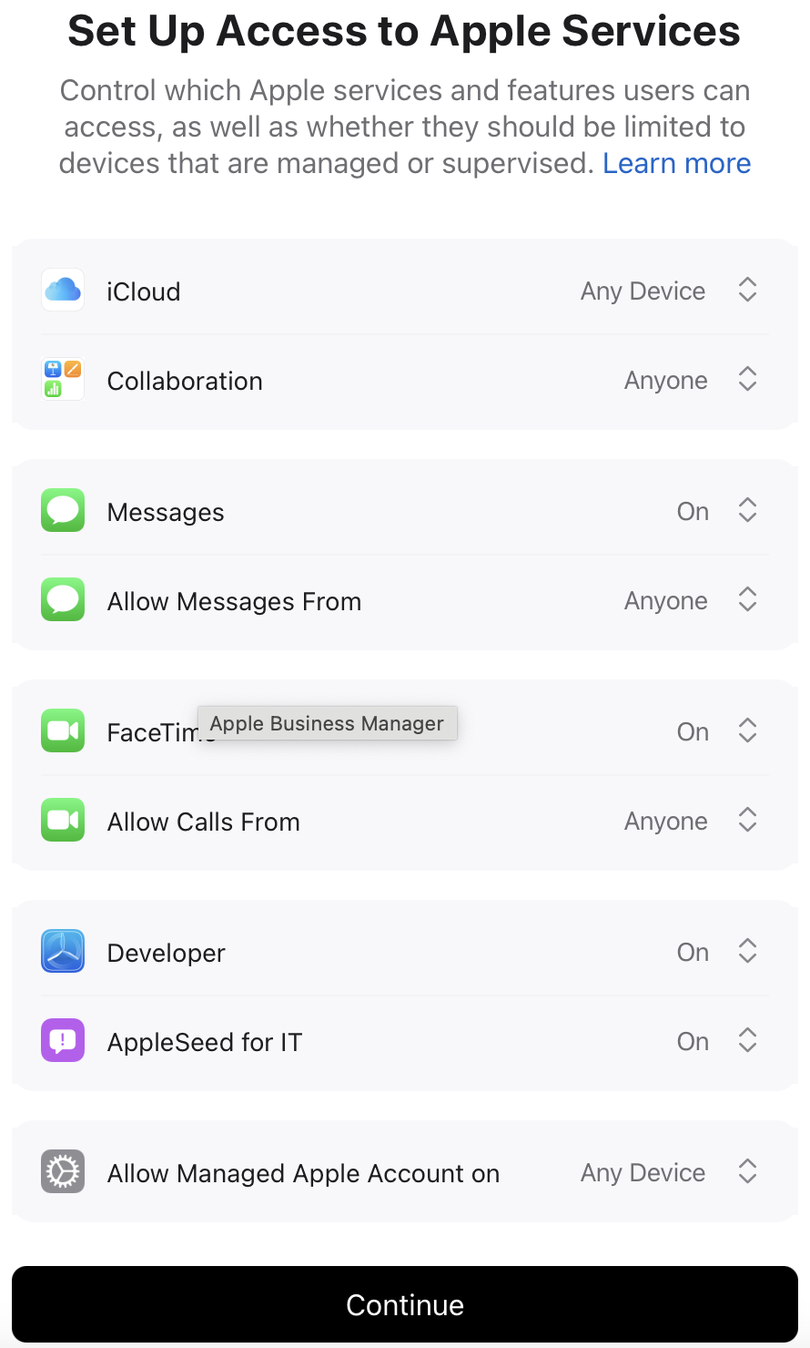
Where can we control Apple services and features of devices whether user can have limited access or managed or supervised
Device management:
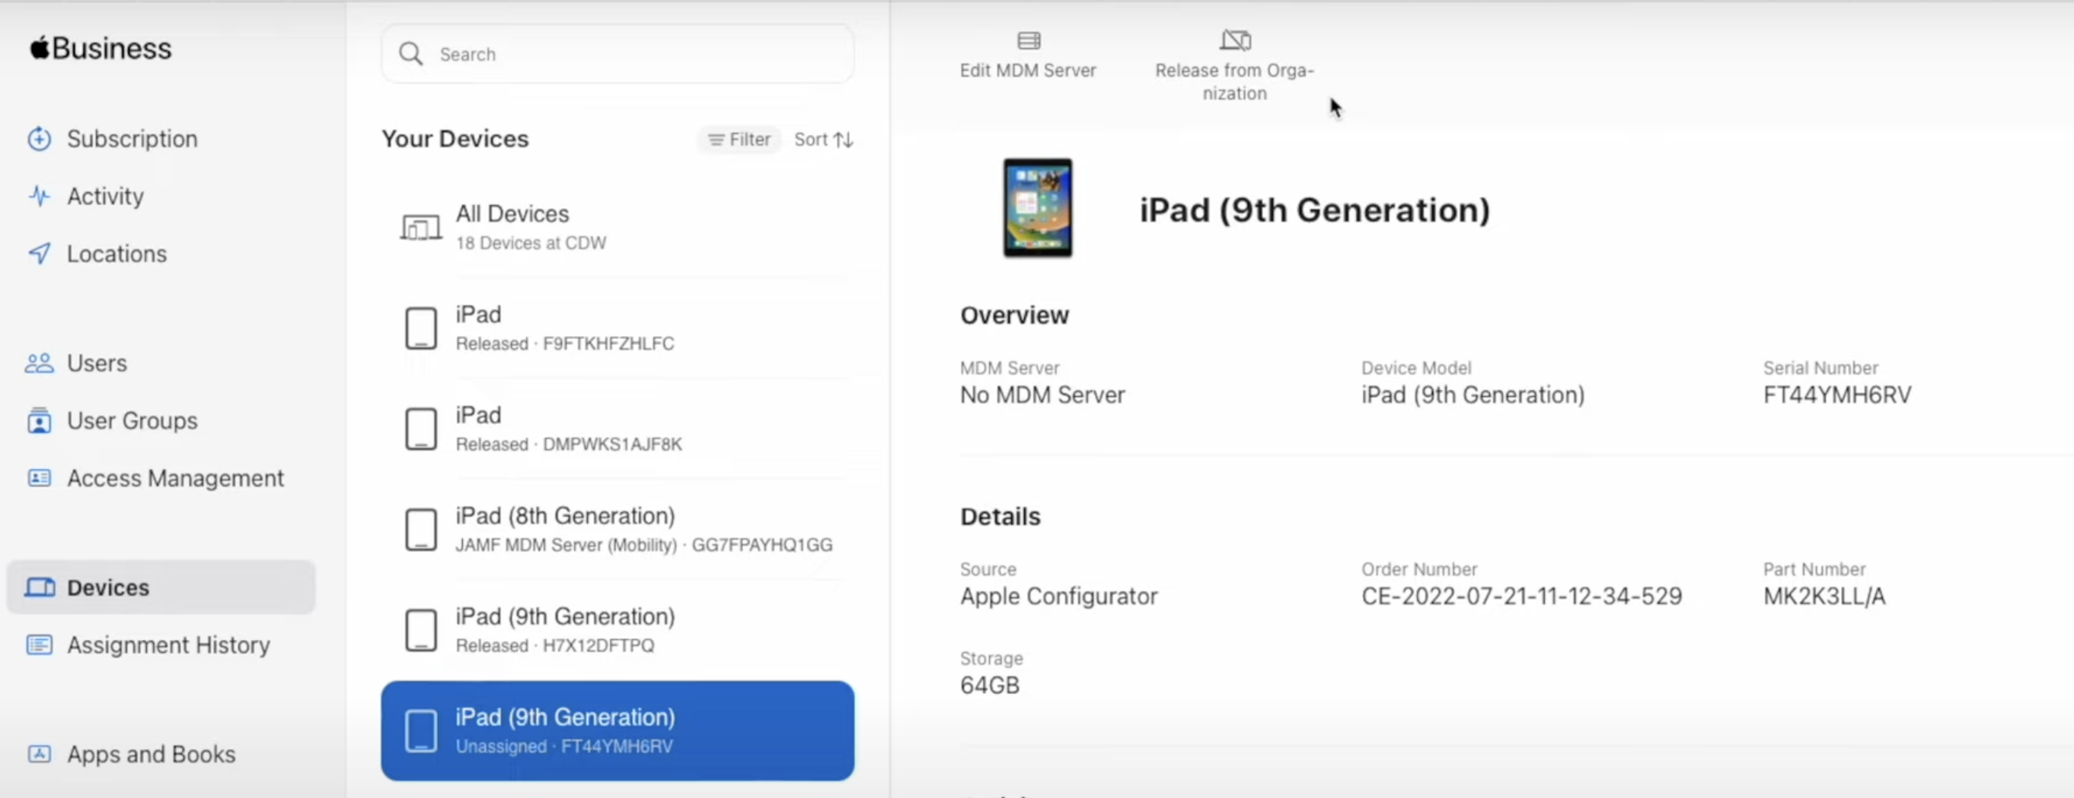

Assignment History: We can Assignment history
Apps:
Store – Apps and custom apps
Add New package
Preferences:
My profile, Organization Information, Payments and Billing, Managed Apple Accounts,

Your MDM Servers:
MDM Server Assignment

Apple Business Essentials
Settings: where can we create configuration profile manage the device or Supervise
Collections: Collections allow you to easily assign apps and settings to your users and devices. When items are added or removed, changes will take place automatically.
Activity:

Microsoft Entra ID & Apple Business Manager Integration

Through the setup and configuration of integrating Apple Business Manager with into Microsoft 365 what that it gives you is allowing your Microsoft 365 accounts and users to sign into Microsoft 365 resources and apple resources like Apple Business Manager Apple ID that will be able to log into any Apple resource and Microsoft 365
If any account gets created in Microsoft 365 will automatically get created in Apple Business Manager if you don't set up provisioning then you can simply create the account in ABM.

Add domain in ABM
Goto managed Apple ID: Domains > Add a domain > Verify the domain with TXT record > Turn On Microsoft Entra ID (it creates federated Domain)
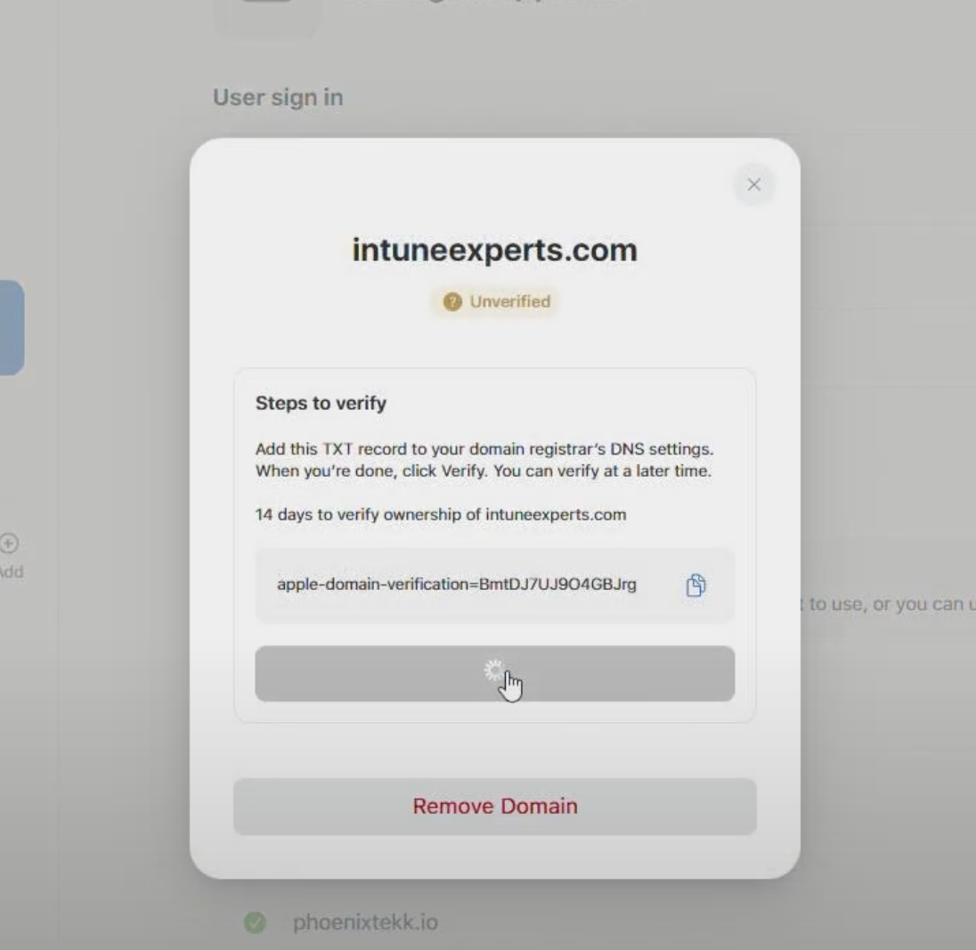
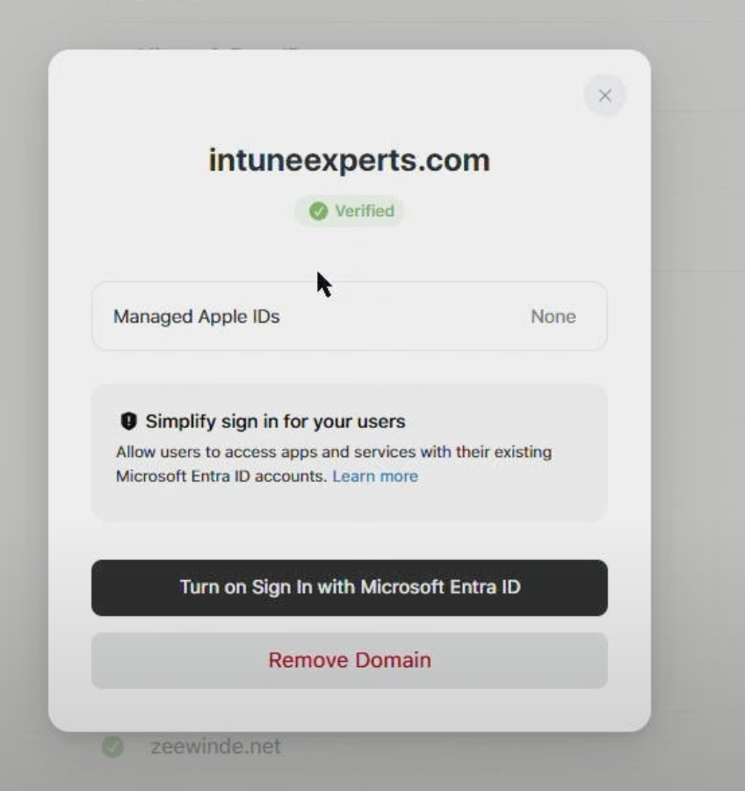
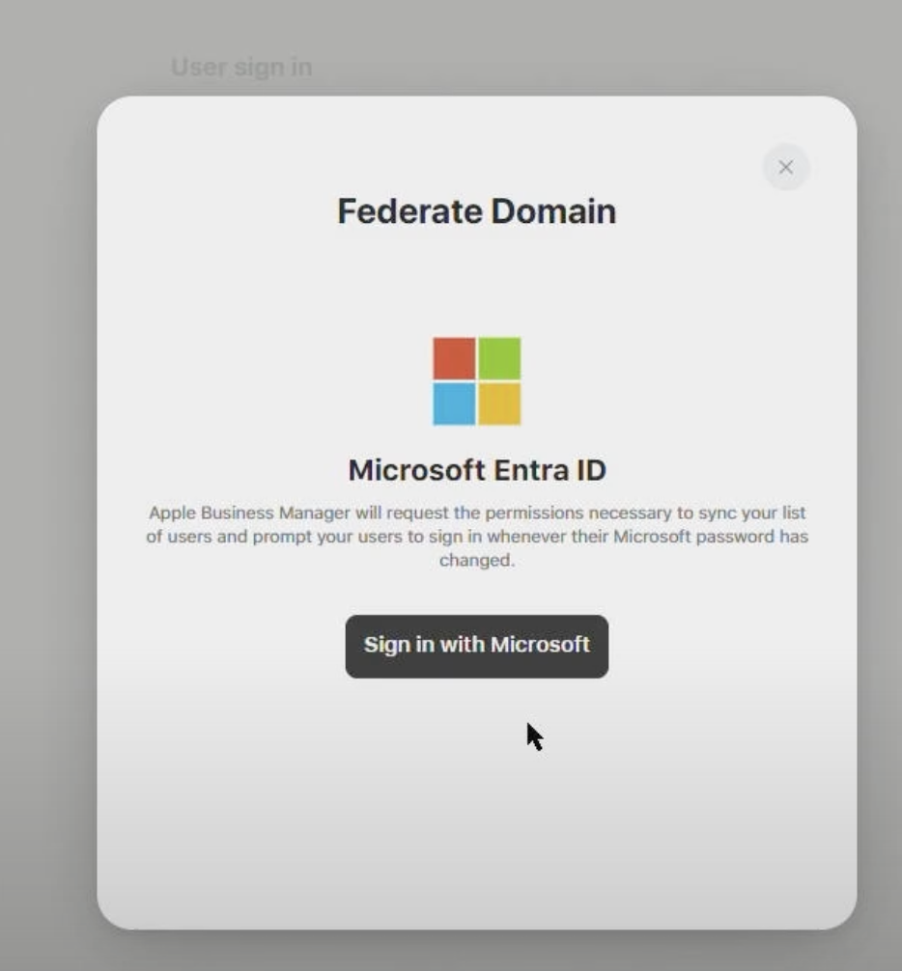
@Here we need to sign with Global Admin account

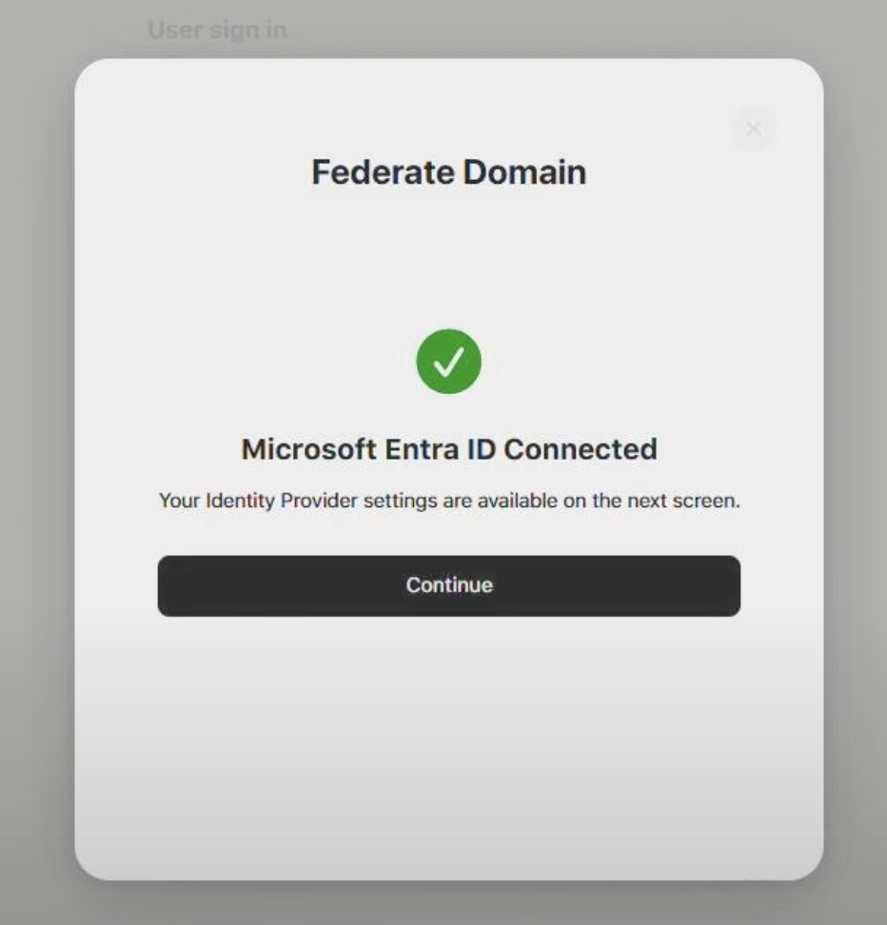
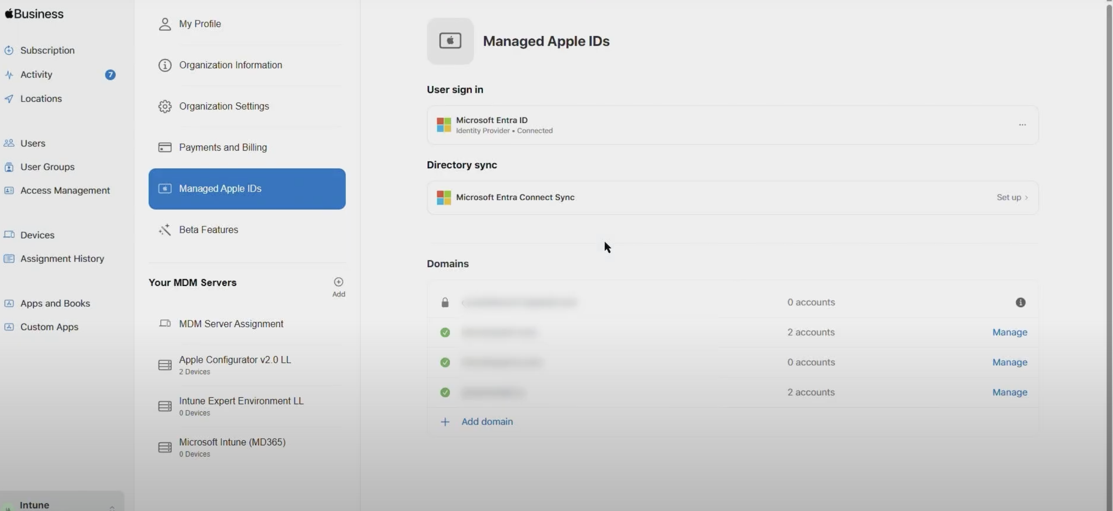
Click on Manage
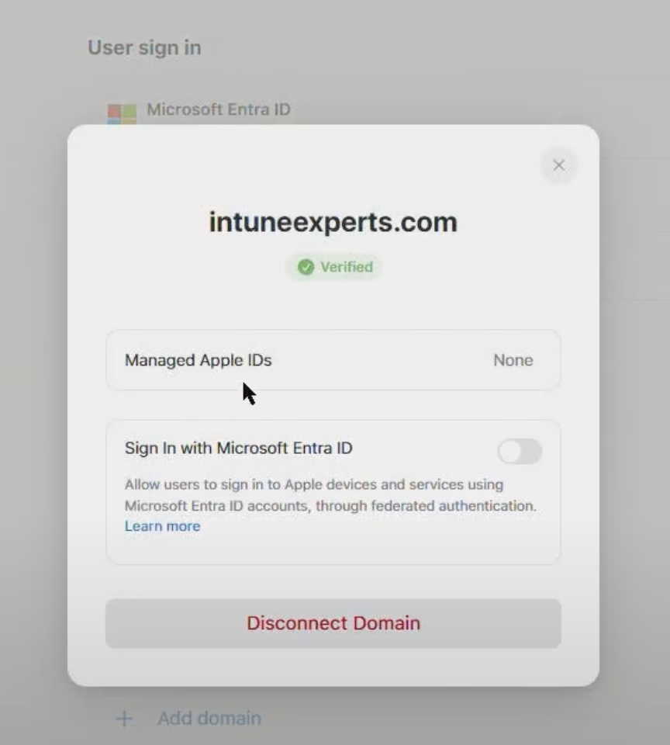

Allow sign in with Microsoft Entra ID. It’s turned on Federated authentication.
TEST

1. create a staff account in ABM
2. sign in with that account portal.azure.com
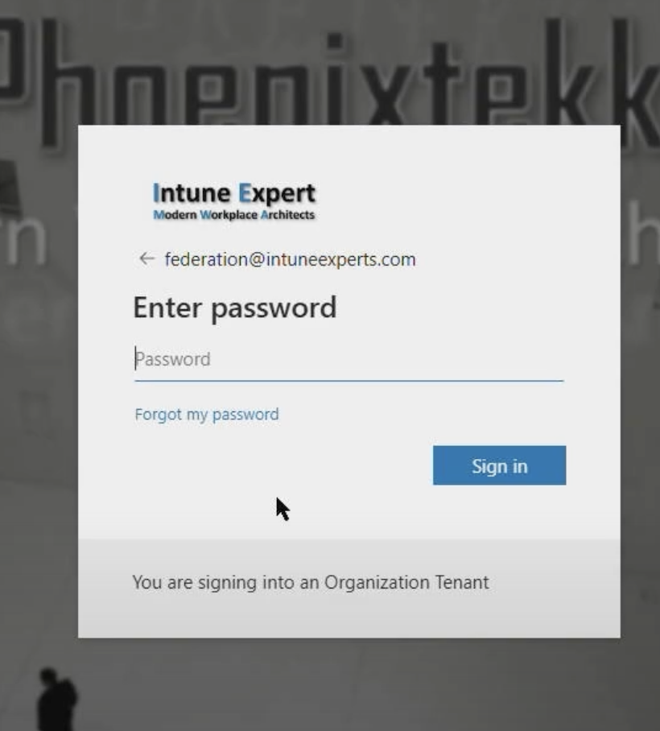
3.try to sign in to applied.apple.com

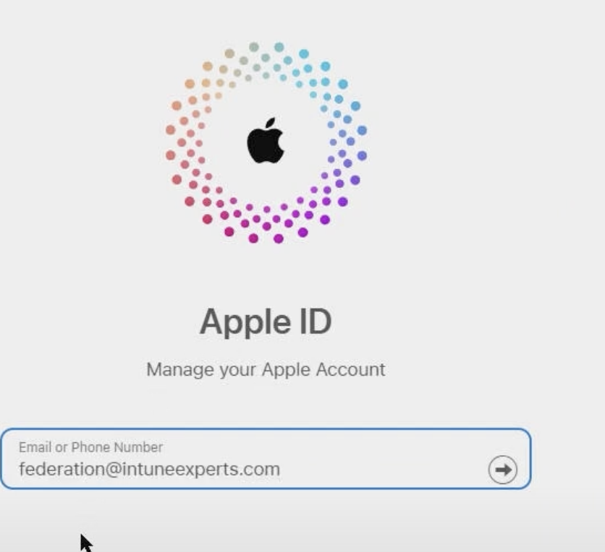
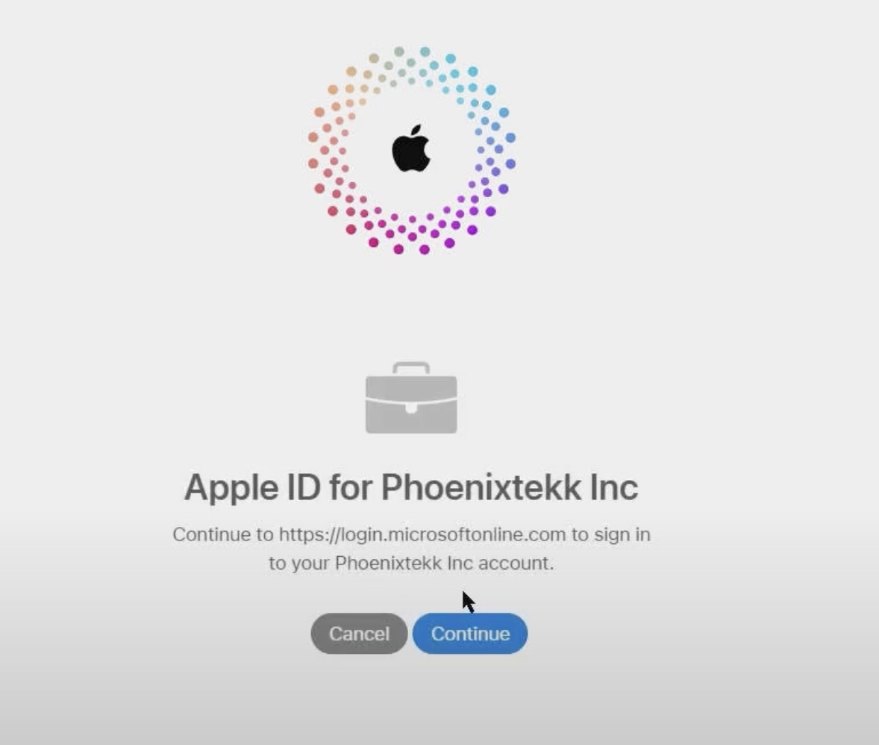
++++++====+++++====++++====++++====++++++======++++=====++++=====

Then go to Portal.azure.com
Microsoft EntraID > Enterprise applications >Apple Business Manager SAML
Provisioning > Provisioning Here we need to Upload the tenet URL from the Apple Bussiness manager
Under Directory sync Microsoft Entra connect sync setup
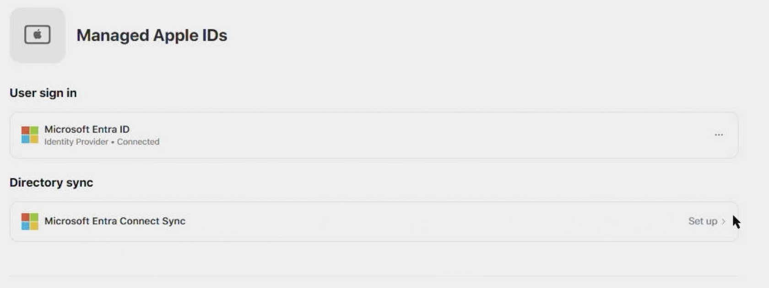

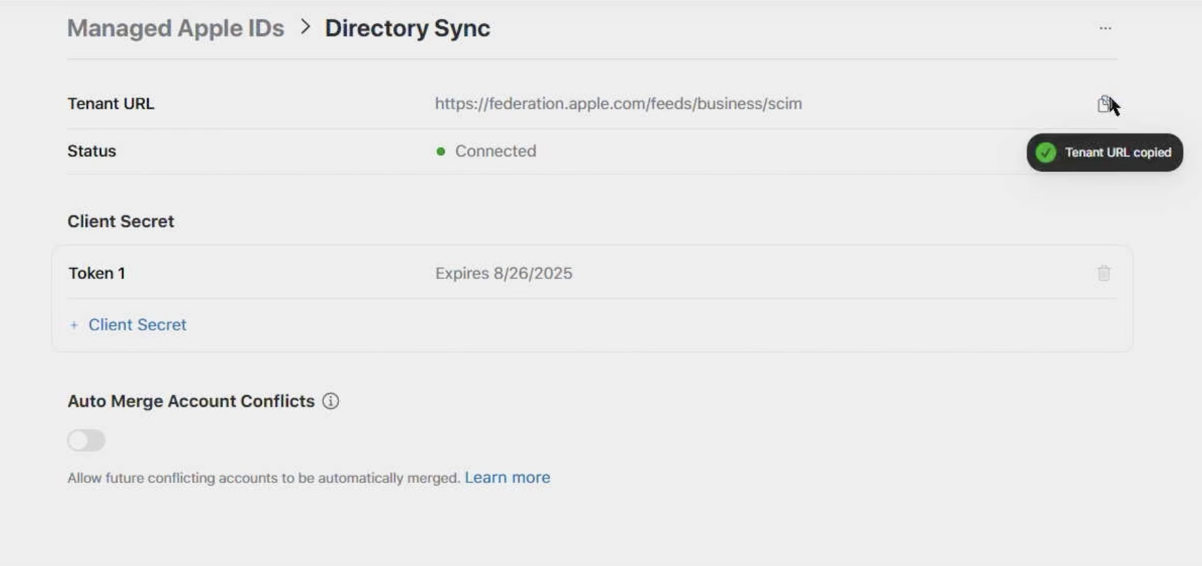

Copy URL and Client secret token
Mapping and setting mail notification
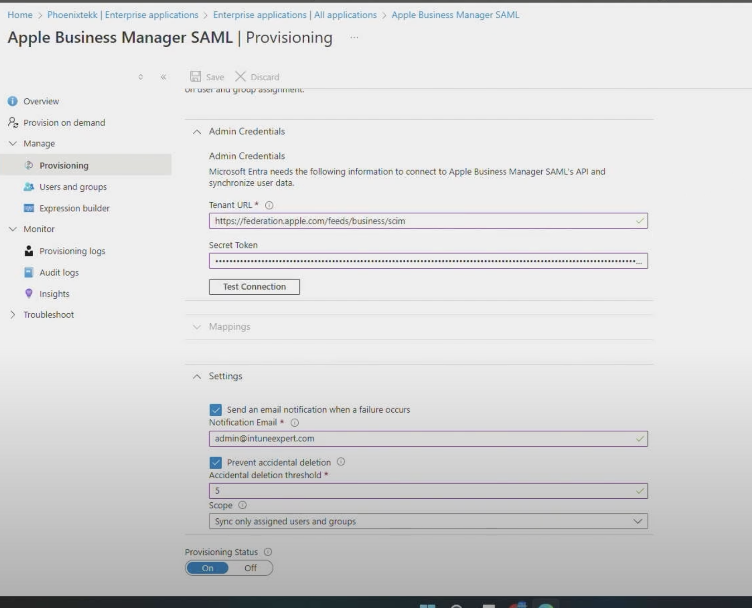
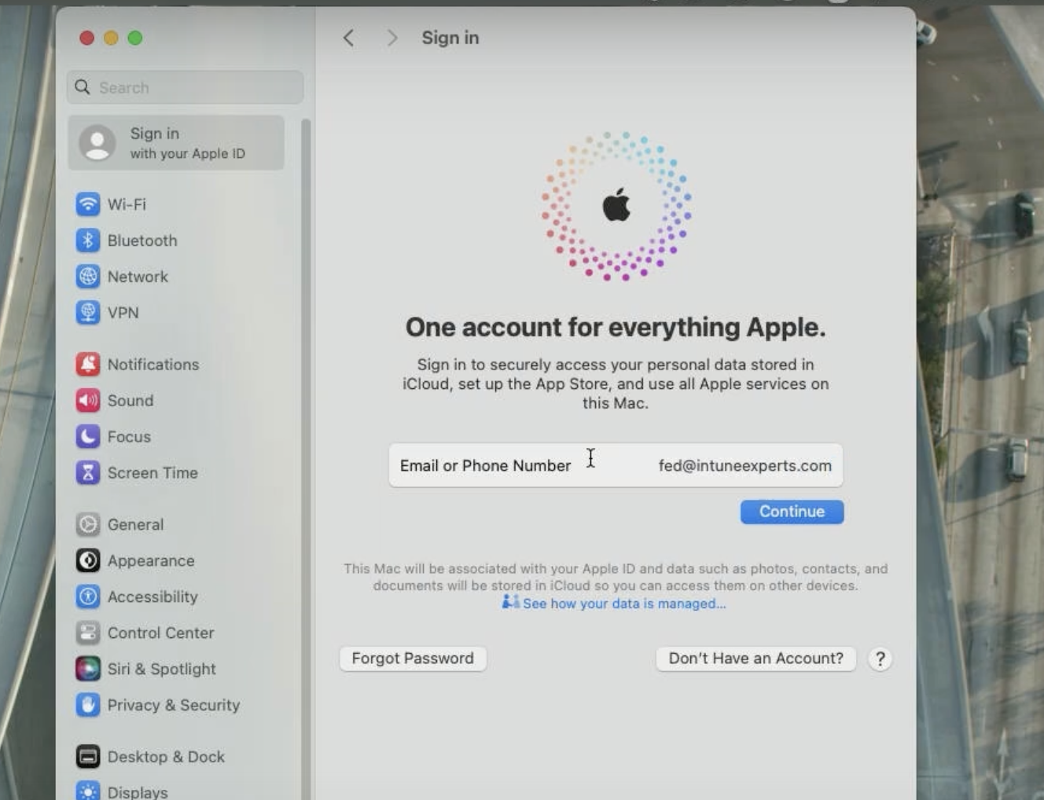
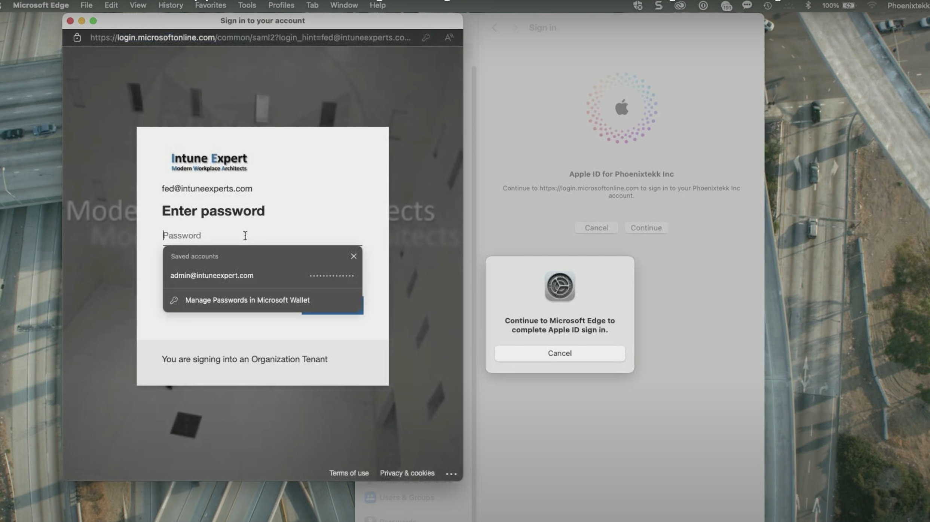

Reserved Domain: A reserved domain is automatically created for any Apple Business Manager organization.
Example: bhanuchander.kudhurla@8bitai1.appleaccount.com
Custom Domain:
If you own a custom domain, you can use it to create Managed Apple Accounts. To do so, the domain must be registered and verified first. The verification process helps to ensure that only the organization who has the authority to modify the domain name service (DNS) records for the domain can create Managed Apple Accounts using that domain.
After a domain is added and verified, you can choose to manage ownership of all Apple Accounts on that domain. See Manage verified domains.
Adding a custom Domain:
There are two ways to add custom domains to Apple Business Manager:
- Manually add a custom domain, then verify it.
- Sync custom domains that are already verified from any identify provider (IdP) that works with Apple Business Manager. For example, you can sync custom domains that are already verified in Google Workspace or Microsoft Entra ID.
